**Test Case 1 – Test basic check in flow**

Description: Test evaluates the check in process happens as intended, after the process the room should be occupied.

Pre-conditions: Booking state should be pending

Post-conditions: Room should be occupied, booking state should be checked in

Data required: A booking with status pending.

Test run:

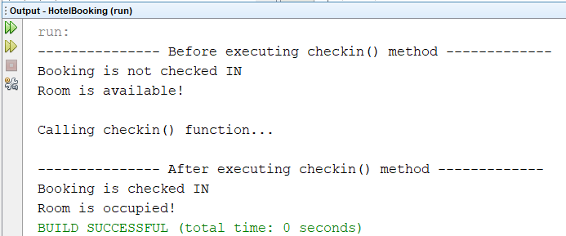

**Test Case 2 – Test the exception in check in function**

Description: Test evaluates what happens when booking state is not pending when check in, an exception should be thrown.

Pre-conditions: Booking state should not be pending

Post-conditions: an exception should be thrown

Data required: A booking with status not pending.

Test run:

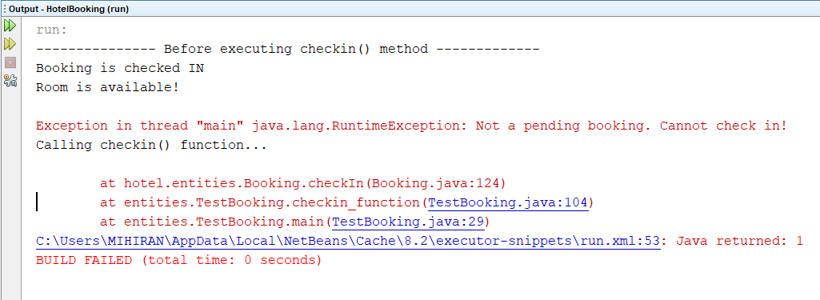

**Test Case 3 – Test basic check out flow**

Description: Test evaluates the basic check out flow, after the checkout, booking state should be checked out and room should be ready.

Pre-conditions: Booking state should be checked in

Post-conditions: Room should be ready and booking state should be checked out

Data required: A booking with status checked in.

Test run:

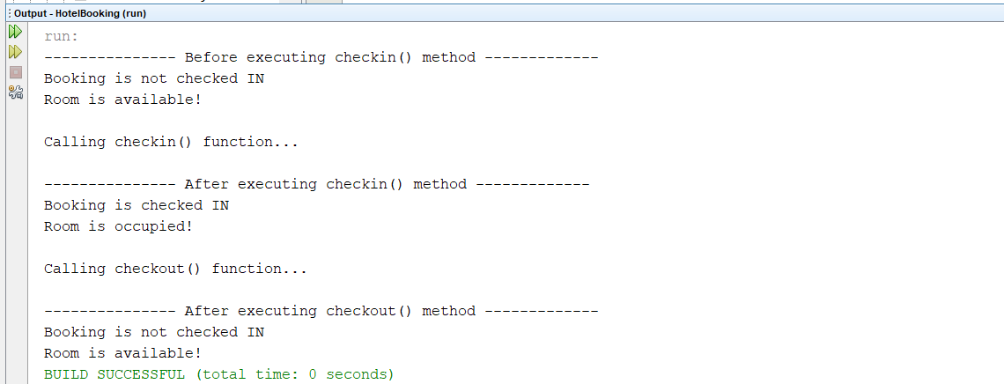

**Test Case 4 – Test the exception in check out function**

Description: Test evaluates what happens when booking state is not checked in when check out, an exception should be thrown.

Pre-conditions: Booking state should not be checked in

Post-conditions: an exception should be thrown

Data required: A booking with status not checked in.

Test run:

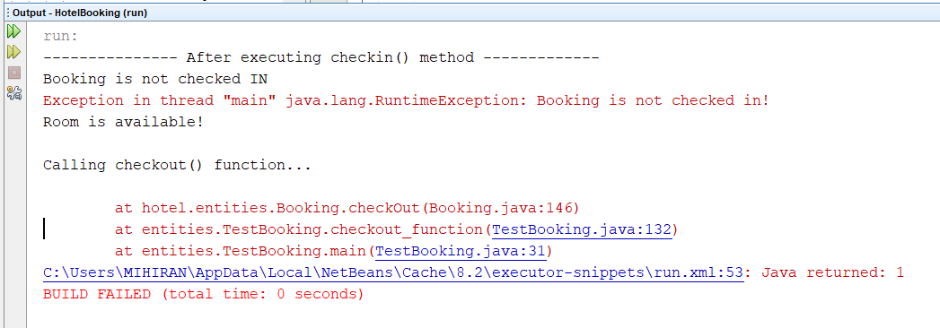

**Test Case 5 – Test adding service charge**

Description: Test evaluates adding service charge is working as intended, after adding service, a list should return with added service charge.

Pre-conditions: Booking state should be checked in

Post-conditions: service charge is added to the services

Data required: A booking with status checked in, a service to add service charge

Test run:

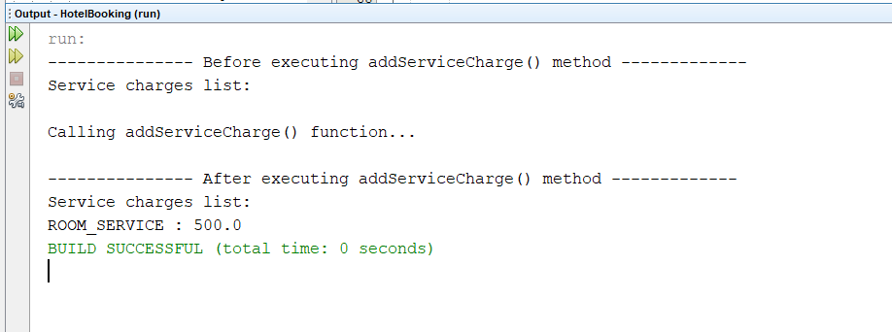

**Test Case 6 – Test the exception in adding service charge**

Description: Test evaluates what happens when booking state is not checked in when adding a service charge, an exception should be thrown.

Pre-conditions: Booking state should not be checked in

Post-conditions: an exception should be thrown

Data required: A booking with status not checked in.

Test run:

